GENETIC ALGORITHMS AND THE MULTIPLE SEQUENCE ALIGNMENT PROBLEM IN BIOLOGY
Kosmas Karadimitriou and Donald H. Kraft
Proceeding of the Second Annual Molecular Biology and Biotechnology Conference.
Abstract

- INTRODOUCTION
2. MULTIPLE SEQUENCE ALIGNMENT (MSA)
Multiple sequence alignment refers to the problem of optimally three or more sequence of symbols with or without inserting gaps between the symbols. The objective is to maximize the number of matching symbols between the sequences and also use only minimum gap insertion, if gaps are permitted.
3. GENETIC ALGORITHMS
- Population
- Chromosome
- Select
- Crossover
- Mutation
4. APPLYING GENETIC ALGORITHMS TO MSA
- MSA without gaps
Example:
Chromosome : 1 2 3 4 5 sequence numbers
4 | 0 | 3 | 2 | 0
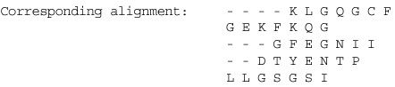
fitness = (total matches) * 1.0
- MSA with gaps
Example:
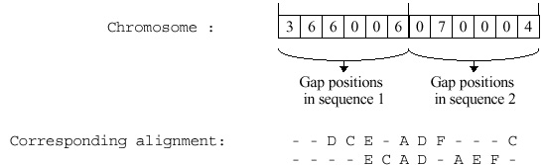
fitness = (total matches) * 1.0 – (gap penalties)
gap penalties = (gap groups) * 4.0 + (total number of gaps) * 0.4
Created by: Ing-Jer Liao
Date: Feb. 19, 2002

